SCENARIO QUESTIONS
$set
A user updates their email address. How do you update only the email field without affecting other data? An order’s status changes from “pending” to “delivered”. How do you update the status field? A product document has no discount field. How do you add it with a value of 10? A nested field address. city needs correction. How do you update only the city? You want to rename a product without changing its price or category. How do you do it?
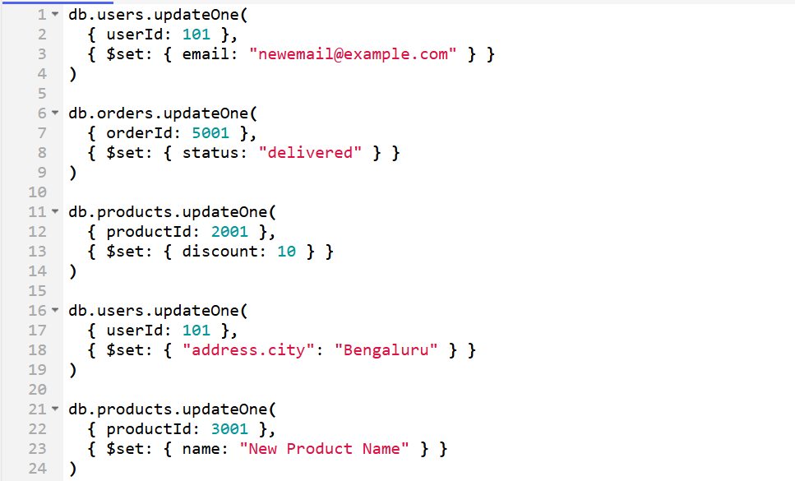
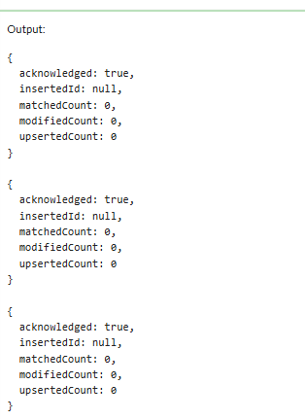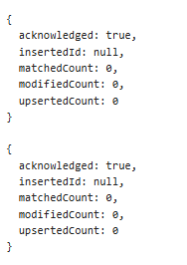

$inc
A user logs in. How do you increase login count by 1? A product is sold once. How do you decrease stock by 1? A wallet balance increases by ₹500 after cashback. How do you update it? A blog post gets a new like. How do you increment the likes count? A product return happens. How do you increase available stock?
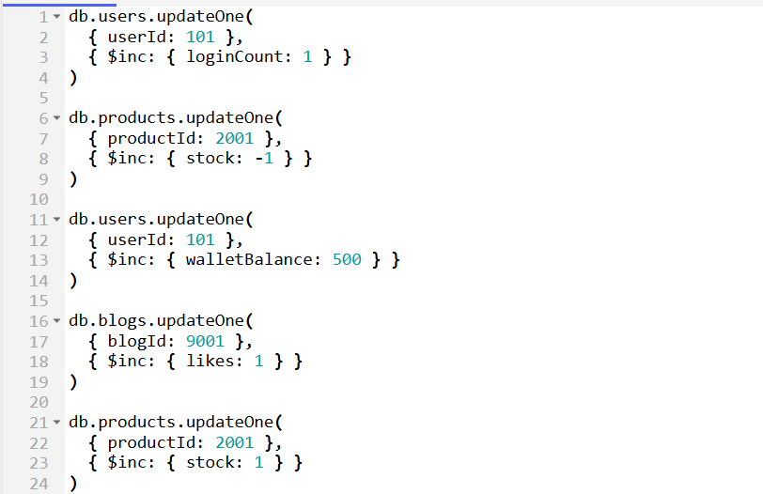
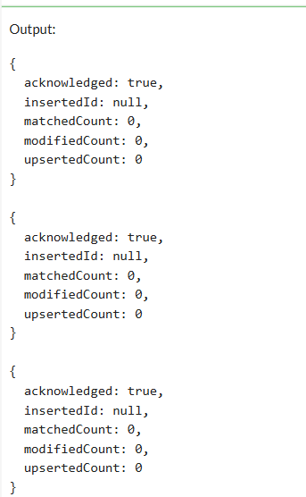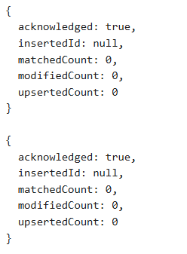

$mul
Apply a 10% price increase to all electronics products. Give a 20% discount on furniture items. Increase salary of all employees by 5%. Apply GST of 18% on product prices. Reduce price by 30% during a sale.
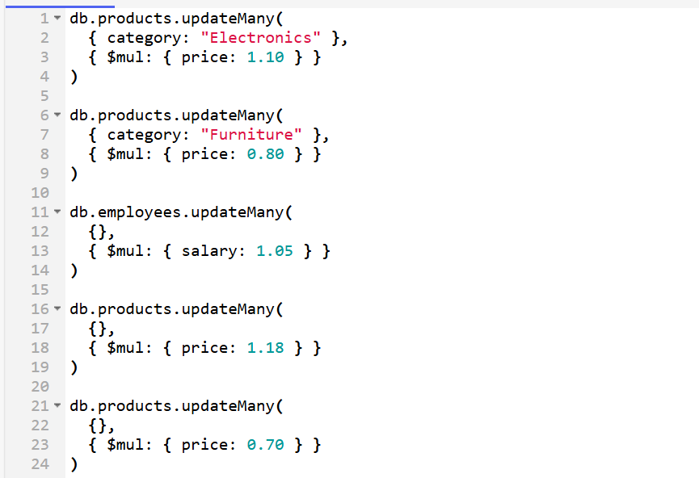
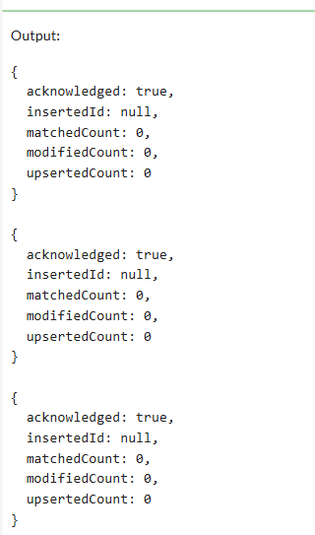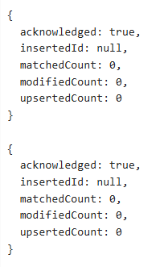
$push
A user adds a new address to their profile. How do you add it to an array? A product receives a new review. How do you add it to the reviews array? A student enrolls in a new course. How do you add the course to an array? An order has multiple products. How do you add one more product to the order? A chat app stores messages in an array. How do you push a new message?
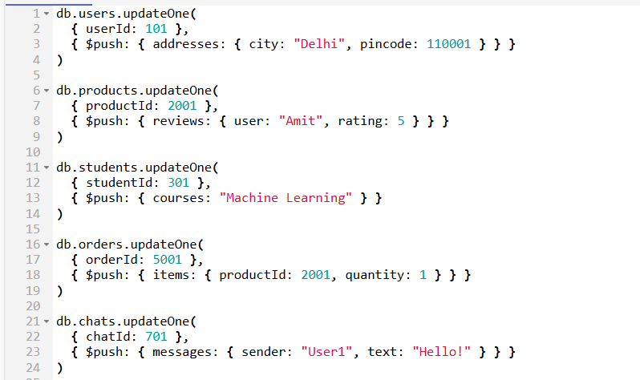
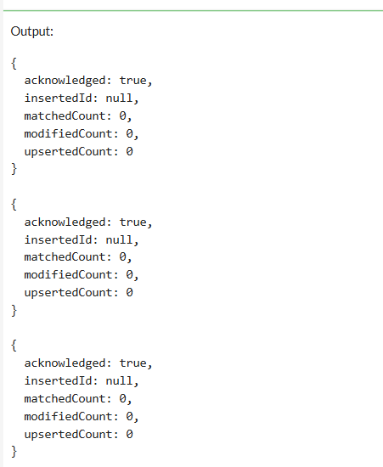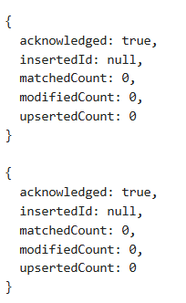
$pull
A user deletes an old address. How do you remove it from the array? A product review violates policy. How do you remove that review? A student drops a course. How do you remove the course from the array? Remove all products with price < 1000 from a cart array. Delete all inactive tags from a product document.
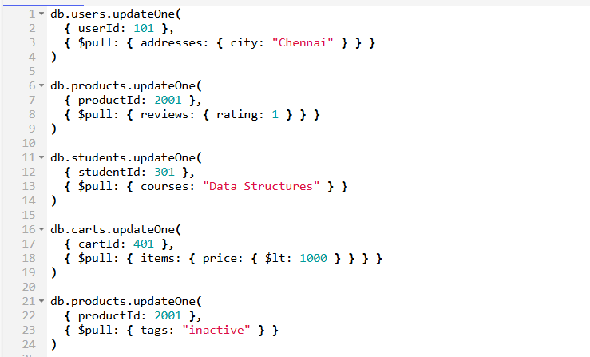
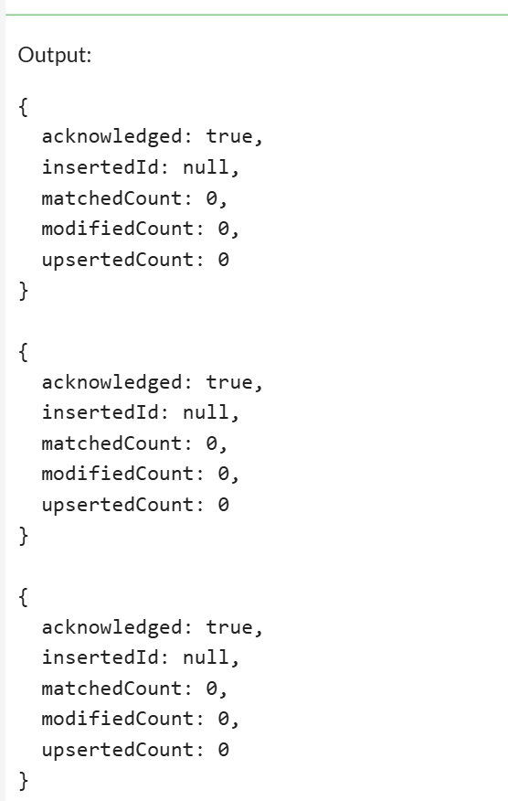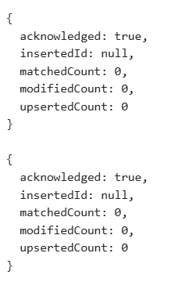

Nested Data & Arrays
Update the quantity of a specific product inside an order’s items array. Change the phone number inside a nested contact object. Increase the salary of employees in a specific department stored in an array. Add a new skill to a specific employee inside an employees array. Remove a specific item from a nested cart array based on product ID.
